Becoming With
Joohyun Kim, MeeNa Park, Yo-E Ryou

일정 2026년 9월 3일(목) – 10월 15일(목)
장소 갤러리시몬 (서울시 종로구 자하문로 6길 20)
문의 T. 720-3031, 549-3031 F. 549-3032
mail@gallerysimon.com www.gallerysimon.com
자료 webhard ID: gallerysimon PW: simon

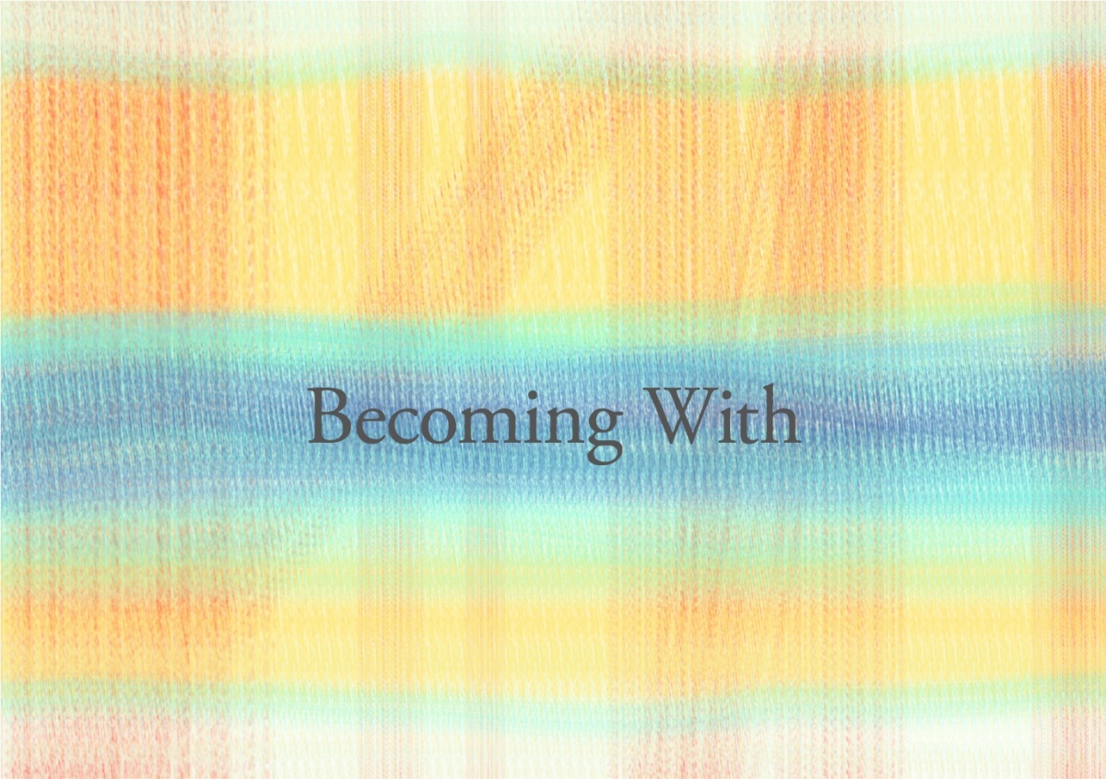

갤러리 시몬은 2026년 9월 3일부터 10월 15일까지 그룹전 <Becoming with>을 개최합니다. 이번 전시는, 관계가 존재를 만든다는 명제를 탐구합니다. 자연과 해녀 공동체를 통해 숨과 몸 그리고 물의 관계를 탐구하는 요이, 위상수학을 기반으로 논리적이고 체계적으로 관계를 확장시켜 빛으로 만들어 나가는 김주현, 색의 이름과 실물의 간극, 그리고 그 편차가 만드는 오해와 소통의 범위에서 관계를 탐구하는 박미나. 하나로 모인 세 작가의 순환은, 홀로 만들어지는 것은 없고 우리는 서로 함께 되거나, 되지 못한다는 것을 보여줍니다.
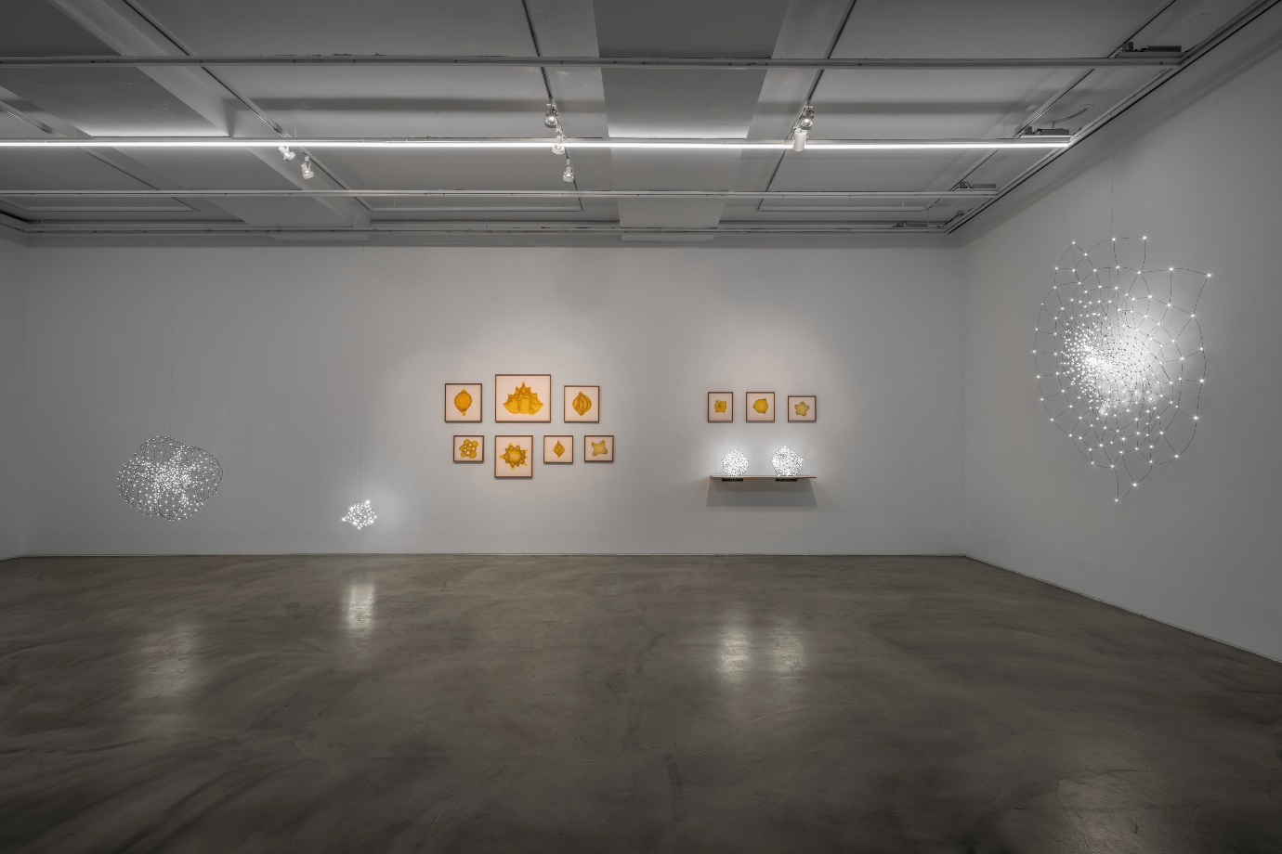
Installation view of Becoming With, Gallery Simon, 2026

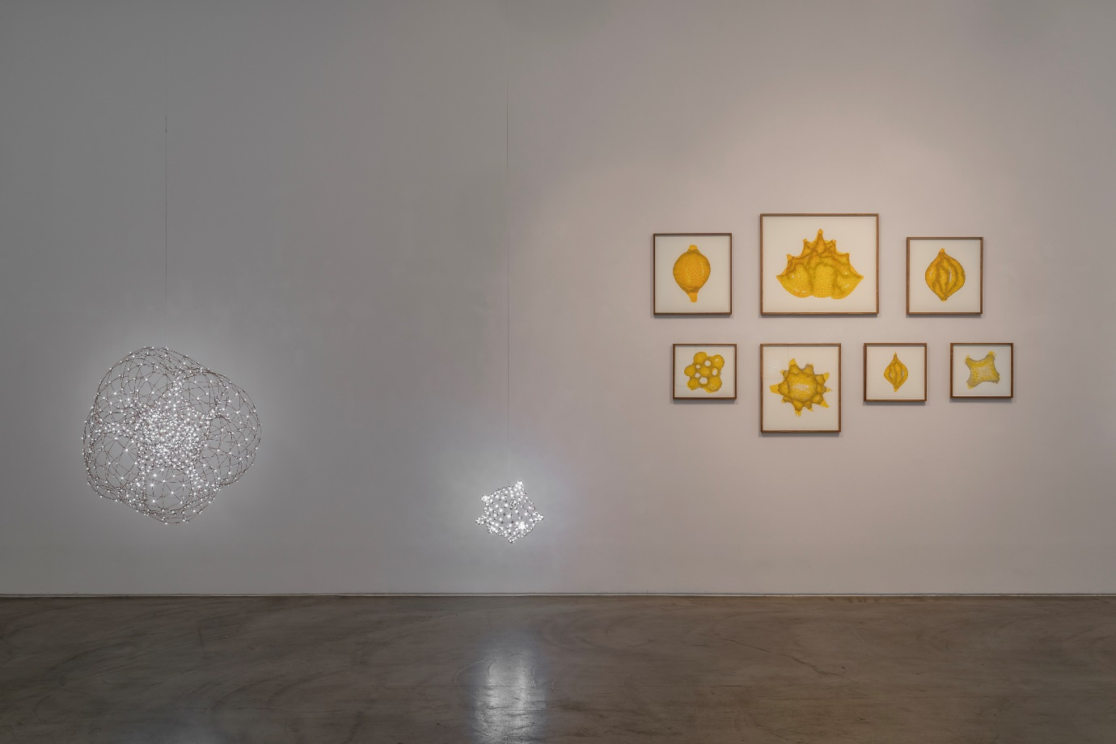
Installation view of Becoming With, Gallery Simon, 2026
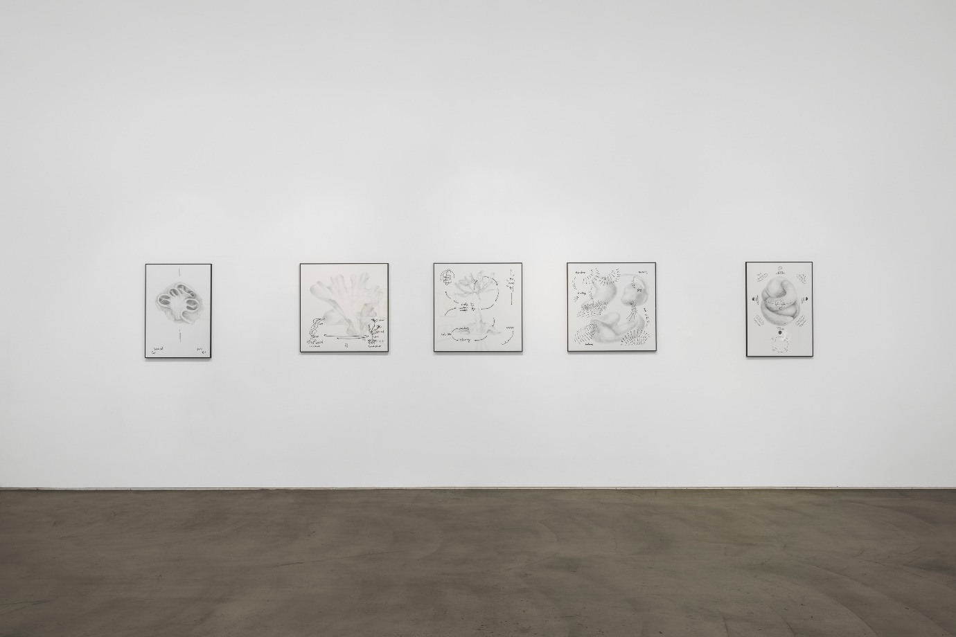
Installation view of Becoming With, Gallery Simon, 2026

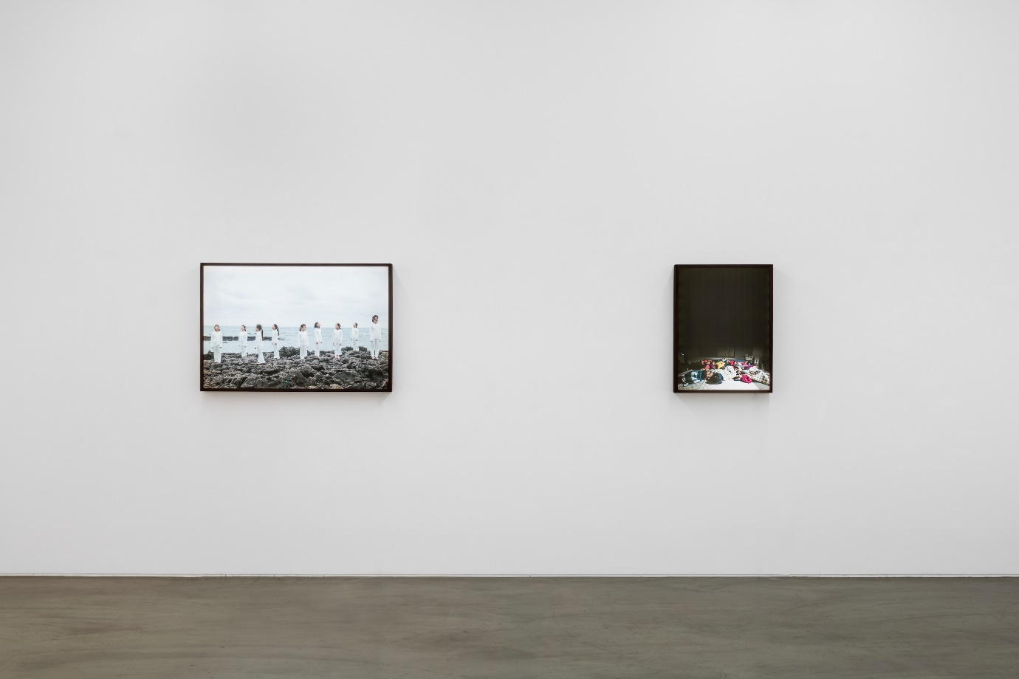
Installation view of Becoming With, Gallery Simon, 2026
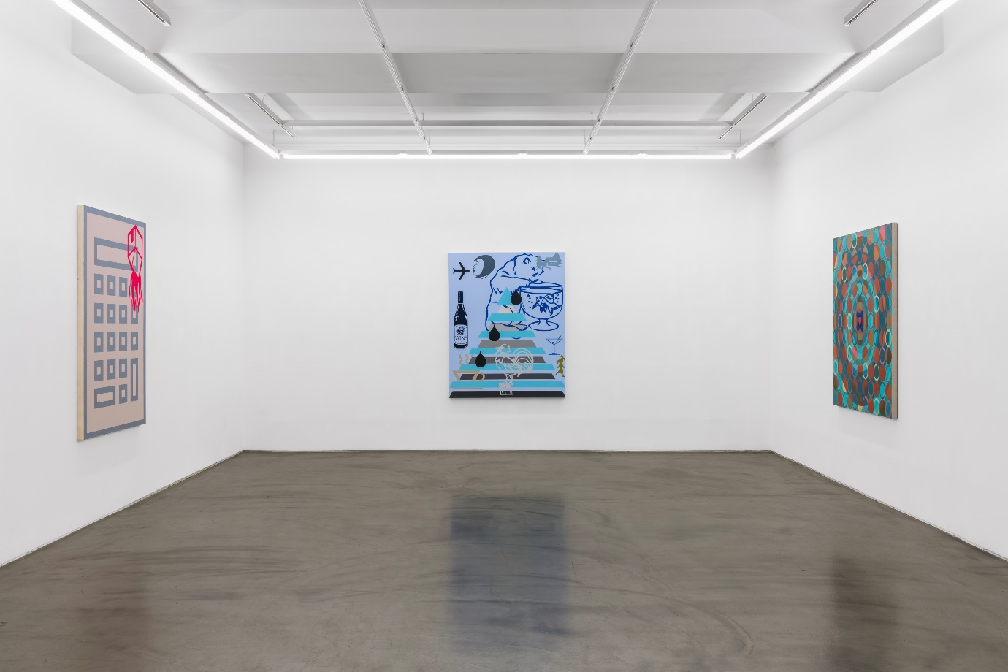
Installation view of Becoming With, Gallery Simon, 2026

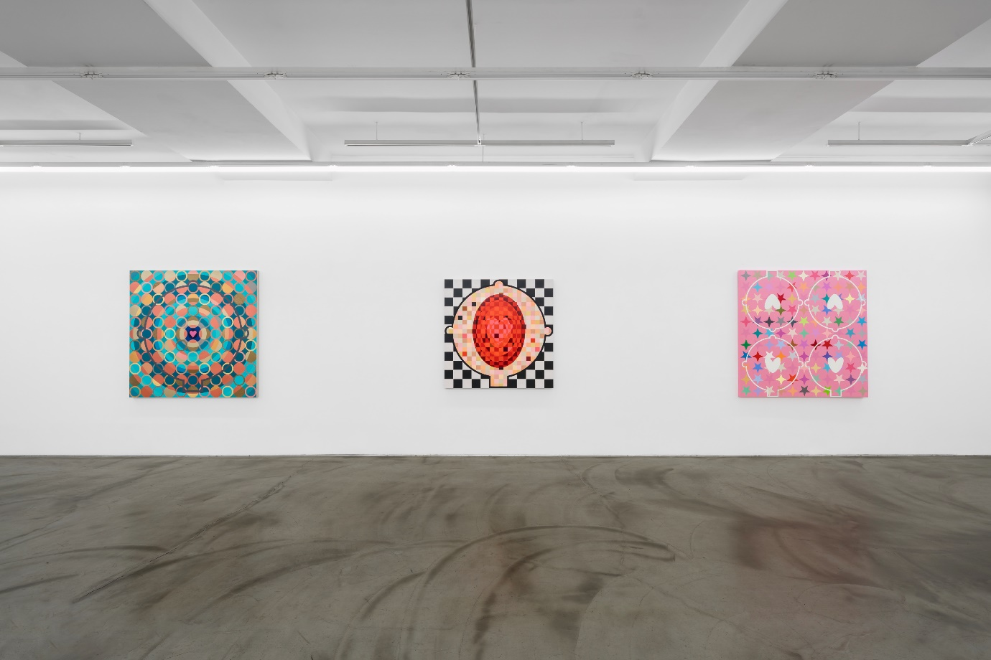
Installation view of Becoming With, Gallery Simon, 2026
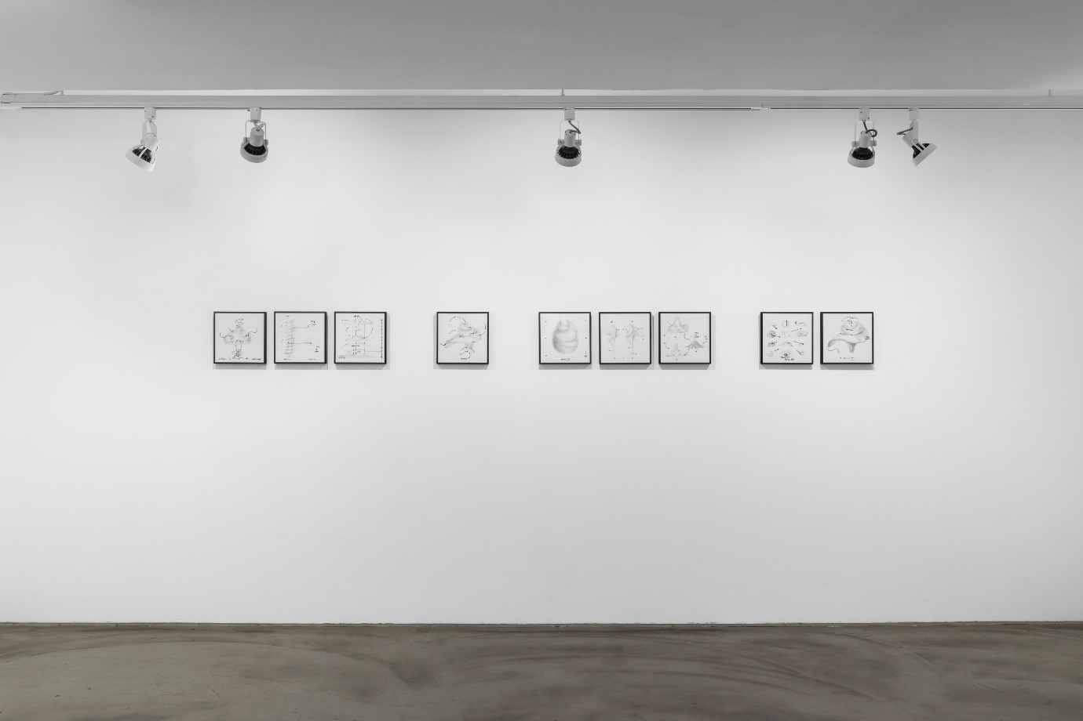
Installation view of Becoming With, Gallery Simon, 2026

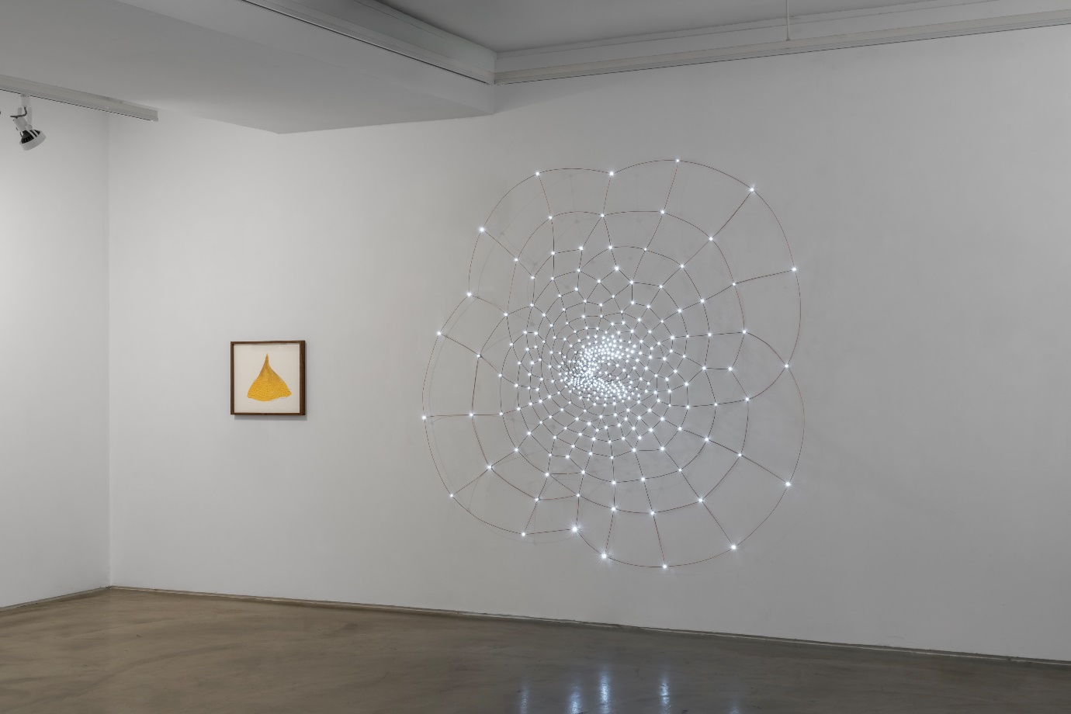
Installation view of Becoming With, Gallery Simon, 2026
김주현 Joohyun Kim
Born in 1965

Education
1991 Diploma at the Hochschule für Bildende Kunste Braunschweig, Germany
1987 BFA, Fine Art College, Seoul National University, Seoul, Korea

Selected Solo Exhibitions
2018 Botanical Architecture, Gallery Simon, Seoul, Korea
Into a Curved Space, SeMA, Buk-Seoul Museum of Art Children’s Gallery, Seoul, Korea
2015 Study on spiral, Gallery Simon, Seoul, Korea
2011 On the Circuit, Gallery Simon, Seoul, Korea
2010 On Warping, Gallery Space, Seoul, Korea
2009 Vision Any Man Alive Dreams of (Anybody’s Dream), Gallery Factory,
Seoul, Korea
2007 Eco-Bridge-2, KT Art Hall, Seoul, Korea
Eco-Bridge-1, Alternative Space Takeout Drawing, Seoul, Korea
2005 The EXTENDED MODE, Kim Chong Yung Sculpture Museum, Seoul, Korea
2004 SIMPLY COMPLEX, Gallery Fish, Seoul, Korea
2003 SIMPLY COMPLEX, Paik Hae Young Gallery, Seoul, Korea
2001 Piling, Project Space Sarubia, Seoul, Korea
1998 Junglim Building, Seoul, Korea
Keumsan Gallery, Seoul, Korea
1997 Jo Gallery, Seoul, Korea
1993 To Art Space, Seoul, Korea

Selected Group Exhibitions
2025 Our Nature, Planetary Coexistence, Seoul Botanic Park, Seoul, Korea
Journey to Distiction, Cheongju Museum of Art, Cheongju, Korea
2024 ZIP, Arko Art Center, Seoul, Korea
Language of the Universe-Numbers, Gwangju Museum of Art, Gwangju,Korea
30th Anniversary Simon’s Friends, Gallery Simon, Seoul, Korea
2023 Yeokdong Variant, Spacemom, Cheongju, Korea
Architecture Becomes Art, Cheongju Museum of Art, Cheongju, Korea
2022 Docking Seoul, Seoul Station, Seoul, Korea
2020 MMCA Artistic Playground, MMCA, Gwacheon, Korea
Art and Energy, Jeonbuk Museum of Art, Wanju, Korea
Collecting for All, Seoul Museum of Art, Seoul, Korea
2019 25th Anniversary Simon’s Friends, Gallery Simon, Seoul, Korea
2017 Garden of chemistry: Blooming flower at the boundary, Korea Research Institute of Chemical
Technology, Daejeon, Korea
Star of Star, Gyeongnam Art Museum, Changwon, Korea
Steel material & immaterial, Pohang Museum of Steel Art, Pohang, Korea
Your Hand, My Heart, Gallery Simon, Seoul, Korea
2016 SeMA Collection: Show Case, Buk Seoul Museum of Art, Seoul, Korea
As the Moon Waxes and Wanes, MMCA, Gwacheon, Korea
SeMA Biennale Mediacity Seoul 2016, SeMA Seosomun Main Building and Branches, Seoul, Korea
2014 The Brain, Daejeon Museum of Art, Daejeon, Korea
Korean Beauty: Two Kinds of Nature, National Museum of Modern and Contemporary Art, Seoul, Korea
Simon’s Friends: 20th Anniversary Exhibition, Gallery Simon, Seoul, Korea
Real DMZ Project, Cheorwon, Korea
Practice for Poetic Space, MMMG Hall, Seoul, Korea
Flora Society, Gallery Factory, Seoul, Korea
2013 Reverscape, Amore Pacific Museum of Art Project, Osan, Korea
Unknown Forces, Tophane I Amire Culture & Arts Center, Istanbul, Turkey
Real DMZ Project, Yangji-ri Residency, Cheorwon, Korea
2012 New & Now: SeMA’s New Acquisitions 2012, Seoul, Korea
Changwon Sculpture Biennale 2012, Dotseom, Changwon, Korea
Busan Biennale: Garden of Learning, Busan Museum of Art, Busan, Korea
2011 Countdown, Culture Station Seoul 284, Seoul, Korea
The New Epicenter: Chapter 1 Post-Nature, Wumin Art Center,
Cheongju, Korea
Volta NY, New York, USA
2010 Chuncheon Romantic Market Arcade Gallery Project, Chuncheon Romantic Market, Chuncheon, Korea
Heteromorphism, Space Gong Myung, Seoul, Korea
2009 The Dream of da Vinci: Art & Techne, Jeju Museum of Art, Jeju, Korea
Cheongju International Craft Biennale, Cheongju, Korea
Green Utopia, Savina Museum of Contemporary Art, Seoul, Korea
Jeju Botanical Garden Art Project 01, Yeomiji Botanic Garden, Jeju, Korea
The First Stop on the Super Highway, Nam June Paik Art Center,
Yongin, Korea
2008 Another Masterpiece: New Acquisition, Gyeonggi Museum of Modern Art, Ansan, Korea
Han River Renaissance, Seoul, SeMA Nam Seoul, Seoul, Korea
2007 Beyond Art, Daejeon Museum of Art, Daejeon, Korea
2006 Fluid Artcanal International, Le Landeron, Swiss & Daejeon, Korea
Turtle’s Tail, Chiwoo Craft Museum, Seoul, Korea
Korean Arts 100 Years, National Museum of Modern and Contemporary Art Korea, Gwacheon, Korea
Budro_um: Softness, Soma Museum, Seoul, Korea
2005 Beyond Repetition, Seoul Museum of Art, Seoul, Korea
Another History of Art; Representation of Feminity, Ewha Womans University Museum, Seoul, Korea
2004 Consonance, Seongbo Museum of Haein Buddhist Temple, Hapcheon, Korea
2002 Beyond Grid, Busan Metropolitan Art Museum, Busan, Korea
2000 Young Korean Artists Exhibition, National Museum of Modern and Contemporary Art Korea, Gwacheon, Korea
1999 Beyond Landscape, Artsonje Museum, Gyeongju & Artsonje Center, Seoul,
Korea
Drawing, Total Museum of Contemporary Art, Seoul, Korea
ETC.

Awards
2005 Kim Se Choong Young Artist Prize
Arts Award of the Year by Arts Council Korea

Residencies
2011 NARS Foundation Residency
2009 Rockefeller Foundation Bellagio Residency
2004 Youngeun Residency, Gwangju, Korea

Public Collections
National Museum of Modern and Contemporary Art, Seoul, Korea
Seoul Museum of Art, Seoul, Korea
Gyeonggido Museum of Art, Ansan, korea
Busan Museum of Art, Busan, Korea
Daejeon Museum of Art, Daejeon, Korea
Jeonbuk Museum of Art, Wanju, Korea
The University of EWHA Womans Art Museum, Seoul, Korea
Heyri Art Valley, Paju, Korea
The National Assembly of the Republic of Korea
ETC.

박미나 MeeNa Park
Born in 1973

Education
1999 M.F.A. Painting Hunter College, City University of New York, New York City, USA
1997 B.F.A. Painting Rhode Island School of Design, Providence, USA

Solo Exhibition
2025 Becoming BK, M&Song Gallery, Seoul, Korea
2024 Image-Generating Human Intelligence Mina, Hana Art Bank, Seoul, Korea
Black, Perigee Hall & Gallery, Seoul, Korea
2023 CV: MeeNa Park & Sasa[44], Art Archives, Seoul Museum of Art, Seoul, Korea
House, One and J. Gallery, Seoul, Korea
Nine Colors & Nine Furniture, Atelier Hermès, Seoul, Korea
Dream Imagination, Seoul Children’s Museum, Seoul, Korea
2022 200579, Gallery Xian, Seoul, Korea
2020 Why Rain Drop Overlapped Blue Faces Golden Bear at the Circus?, Audio Visual Pavilion, Seoul, Korea
2019 SMSM10, Audio Visual Pavilion, Seoul, Korea
Scream, Over the Influence Gallery, Hong Kong
2017 MeeNa Park: Artist’s Palette, Gyeongju Arts Center, Gyeongju, Korea
2016 KPS Photography, Mapo Gallery, Mapo Lifelong Learning Center, Seoul, Korea
Scream, Audio Visual Pavilion, Seoul, Korea
MeeNa Park: Artist’s Palette, Buk-Seoul Museum of Art, Seoul, Korea
2015 24 & 36 Grays, Gallery EM, Seoul, Korea
2013 Grey & 12, Kukje Gallery, Seoul, Korea
2012 Drawings 1998-2012, Doosan Gallery, Seoul, Korea
Gray Sky, Doosan Gallery New York, New York City, USA
2011 AZ, Gallery EM, Seoul, Korea
2010 BCGKMRY, Kukje Gallery, Seoul, Korea
2009 The Power of Color, Gyeonggi Museum of Modern Art & Danwon Health Center, Ansan, Korea
(?_?)(=_+)(+_+), Korea Art Center, Busan, Korea
Rama Lama Ding Dong, Atelier Hermès(Jackson Hong), Seoul, Korea
2008 Blue, Green & Red, Kim Jinhye Gallery, Seoul, Korea
MeeNa & Sasa[44] Kukje 080307-080406, Kukje Gallery, Seoul, Korea
2007 Home Sweet Home, Project Space SarubiaDabang, Seoul, Korea
Curating Degree Zero Archive, Arts Council Korea Insa Art Space, Seoul, Korea
2006 Black Pen and Blue Sky, Kim Jinhye Gallery, Seoul, Korea
2005 Scream, One and J. Gallery, Seoul, Korea
2004 MeeNa Park, Sindoh Art Space, Seoul, Korea
2003 5=1, Gallery Biim, Seoul, Korea
Blythe+, Do Art Gallery, Seoul, Korea
HAHAHA: Emerging IV: MeeNa & Sasa[44], Ssamzie Art Space, Seoul, Korea
2002 MeeNa Park, Seoul Auction House Chungdam, Seoul, Korea
1996 MeeNa Park, Benson Hall Gallery, Providence, USA

Group Exhibition
2026 One In, One Out, Suwon Art Space Gwanggyo. Suwon, Korea
2025 KITSCH & POP: Korean Pop Art Now, Korean Cultural Center in Hong Kong, Hong Kong
KITSCH & POP: Korean Pop Art Now, Korean Cultural Center in Shanghai, Shanghai, China
Ready…Set…Color, Jeonnam Museum of art, Gwangyang, Korea
Deep into Abstraction – On the Way, Seoul National University Museum of Art, Seoul, Korea
Wonder Square, Museumhead, Seoul, Korea
Take My Eyes Off, Buk-Seoul Museum of Art, Seoul, Korea
Contemporary Art Ccollection, Leeum Museum of Art, Seoul, Korea
2024 PERIGEE WINTER SHOW 2024, Perigee Gallery, Seoul, Korea
From Where to Where, Hello Museum, Seoul, Korea
The 7th Changwon Sculpture Biennale : Silent Apple, Seongsan Art Hall, Changwon, Korea
Singapore Design Week 2024: People of Design Showcase Series, SHOP Bugis+ Bras Basah Bugis, Singapore
2023 Cheek to Cheek, S2A Space, Seoul, Korea
Décor·Décor: Living Room Arcade, Ilmin Museum of Art, Seoul, Korea
S, M, SM, SMSM, Temporary Unit, Singapore
Still-Life Still-City, Sehwa Museum of, Seoul, Korea
Support SARUBIA, Project Sarubia, Seoul, Korea
TGC 6th Anniversary Exhibition, The Great Collection, Seoul, Korea
Non Fungible Art, Miro Center, Gwangju Metropolitan City, Korea
2022 The Fool on the Hill, ONE AND J. Gallery, Seoul, Korea
The Viewing Room, A Project Company, Seoul, Korea
Chucanet, Audio Visual Lab, Seoul, Korea
Nostalgia Through Noise, Prompt Project, Seoul, Korea
Unboxing Project: Today, New Spring Project, Seoul, Korea
Poetic Collection, Seoul Museum of Art, Seoul, Korea
Support SARUBIA, Project Space Sarubia, Seoul, Korea
2021 2021 Seoul International Book Fair: Gutnit: New World Coming, S-Factory, Seoul, Korea
Crossover, Kyung Hee University Museum, Seoul, Korea
Open Codes: Networked Commons, Nam June Paik Art Center, Yongin, Korea
Making a Garden, Piknic, Seoul, Korea
ETC.

Awards
2020 Minister Award 2020, Ministry of Culture, Sports and Tourism of Korea
2010 The 1st DOOSAN Artist Award, Doosan Yonkang Foundation, Seoul, Korea
International Exhibition Grant, Seoul Foundation for Arts and Culture, Seoul, Korea
2005 Outstanding Lecturer Award, Sungkyunkwan University, Seoul, Korea
1997 Florence Leif Award, Department of Painting, Rhode Island School of Design, Providence, USA

Residency
2012 DOOSAN Residency New York, New York City, USA
2009 Tokyo Wonder Site, Tokyo, Japan
2005 Youngeun Museum of Contemporary Art: Kyung-An Artist Residency, Gwangju, Korea
2004 The Jerusalem Center for the Visual Arts (JCVA), Jerusalem, Israel
2002 SSamzie Art Space Residency, Seoul, Korea

Public Collection
Gyeonggi Museum of Modern Art, Ansan, Korea
National Museum of Modern and Contemporary Art, Korea
National Taiwan Museum of Fine Arts, Taichung, Taiwan
Daelim Museum, Seoul, Korea
Leeum Museum of Art, Seoul, Korea
Ssamzie Art Space, Paju, Korea
Seoul Museum of Art, Seoul, Korea
Sehwa Art and Culture Foundation, Seoul, Korea
Suwon Museum of Art, Suwon, Korea
Youngeun Museum of Contemporary Art, Gwangju, Korea
Ilmin Museum of Art, Seoul, Korea
ETC.

요이 Yo-E Ryou
Born in 1987

Education
2018 MFA, Yale University, School of Art, New Haven, USA
2012 BFA, Rhode Island School of Design, Providence, USA

Selected Solo Exhibitions
2026 Echoes of the Tides, Music Box Gallery, Musée du Quai Branly, Paris,France
2025 The 25th Song Eun Art Award Exhibition, Song Eun, Seoul, Korea
Breath Pause, Forever Gallery, Seoul, Korea
2023 Why I Swim, Alternative Space LOOP, Seoul, Korea
2020 Auspicious Practice, Gallery Maejum, Seoul, Korea
Etc.

Selected Group Exhibitions
2026 The 61st International Art Exhibition – La Biennale di Venezia, In Minor Keys, Venice, Italy
Life on Earth: Art and Ecofeminism, West, The Hague, Netherlands
Touchy Feely: Seoul, Alternative Space LOOP, Seoul, Korea
Windmill AIR: Performance Festival, Seoul, Korea
Art festa in Jeju: An Unrecovered Island, Five Breath, Sanjicheon Gallery, Jeju, Korea
Manifesto for Sustainable Experimentation, Beaconsfield Gallery, London,UK
2024 Life on Earth: Art and Ecofeminism, The Brick, Los Angeles, USA
Swimming as Resistance, Performance, Forever Gallery, Seoul, Korea
Boundless: Language of the Soul, Jeju Gallery, Seoul, Korea
Gangwon International Triennale: Ecological Art from Beneath, Korea
Yeosu International Art Festival: Soul Food & Black Cocktail, Yeosu Expo, Yeosu, Korea
2018 Medusa With The Head, 263 Bowery, New York City, USA
Etc.

Talks & Readings
2025 Why I Swim, Reading Performances, Dear Friend Books, Brooklyn, USA
Why I Swim, Reading Performances, Open Paviljoen, The Hague,Netherlands
Why I Swim, Reading Performances, Preview Art Fair, Seoul, Korea
Why I Swim, Reading Performances, Feeled Lab Symposium, Canada
2024 Swimming as Labour, Speaker, Gender Research Center, Gwangju, Korea
Swimming as Resistance, Panelist, Female Workers and Ecofeminism, Gangwon International Triennale Symposium, Seoul, Korea
Swimming as Disappearance, Reading Performance, Institute of Postnatural Studies, Madrid, Spain
2023 Why I Swim, Artist Talk, The School, Hasselt, Belgium
Alternative Realities, Speaker, SNU International Design Culture Conference, Seoul, Korea
At Land and Sea:Topographical Imagination And The Moving Image, Speaker, Istanbul, Turkey
2022 Watery Studies: Water, Womxn, Jeju, Speaker, Eco-Feminism Symposium,
Art Space LOOP, Seoul, Korea

Residencies & Research
2026 Malt AIR Artist Residency (upcoming), Ebeltoft, Denmark
2025–26Residence Sonore Laureate, Musee du Quai Branly × Le Fresnoy, France
2025 Institute of Postnatural Studies, Postnatural Individual Program, Madrid, Spain
2024 Postnatural Individual Program, Institute of Postnatural Studies, Madrid, Spain

Awards & Grants
2026 ILWOO PRIZE, ILWOO Foundation
Interdisciplinary Arts Grant, Seoul Foundation for Arts and Culture
International Exhibition Grant, Korean Arts Council
2025–26International Exchange Grant, Jeju Foundation for Arts and Culture
2024–25Advanced Emerging Artist Grant, Jeju Foundation for Arts and Culture
2023 Artistic Research Grant, Jeju Foundation for Arts and Culture
2023 Art Space Grant, Jeju Foundation for Arts and Culture
2022 Korean Film Council

